Equipment needed

Paintbrushes - Size 1,3 and 000
Drill (optional)
Magnets (optional)
Spray can of primer (colour optional – I prefer Grey)
Aircraft model(s)
Vallejo paints – 912 Tan Yellow
986 Deck Tan
846 Mahogany Brown
850 Medium Olive
965 Prussian Blue
823 Luftwaffe Camo Green
Other colours – Black
White
Leather brown
Red
Yellow
Decals

Stage 1 (optional) – Drill base of plane and mount magnet
Stage 2 – Spray whole plane with primer
Stage 3 – Paint upper surfaces Tan Yellow
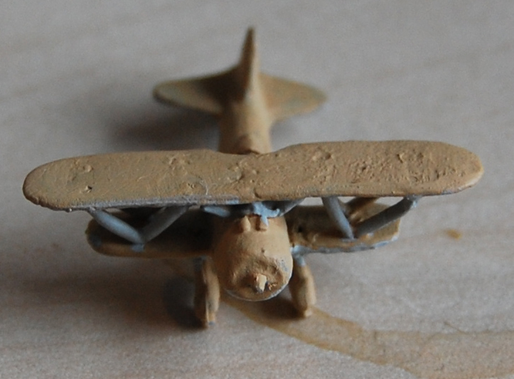

Stage 4 – Paint under surfaces with Deck Tan
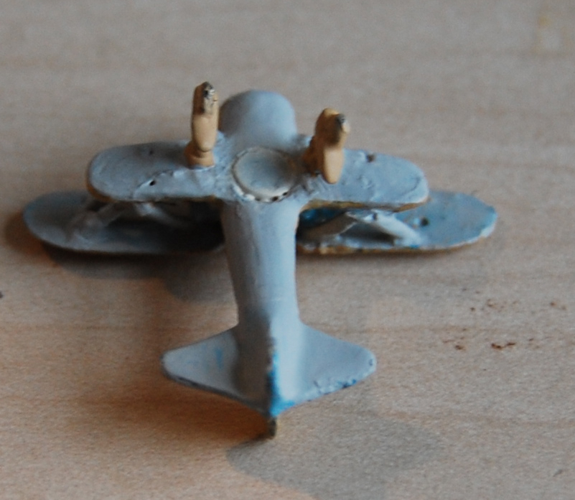

Stage 5 – Paint Blotches of Mahogany over the Tan Yellow
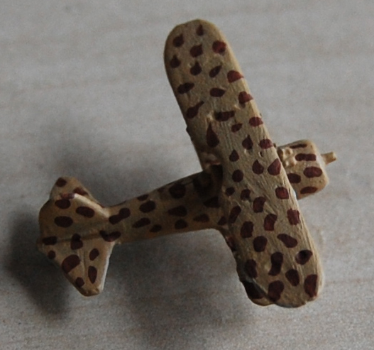

Stage 6 – Paint Blotches of Medium Olive on the Tan Yellow
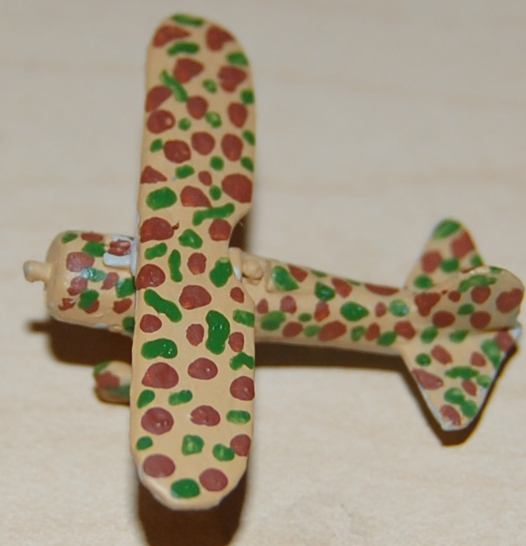

Stage 7 – Paint engines/wheels and open cockpits black
Stage 8 – Paint pilot leather brown
Stage 9 – Paint Numbers in White and Red
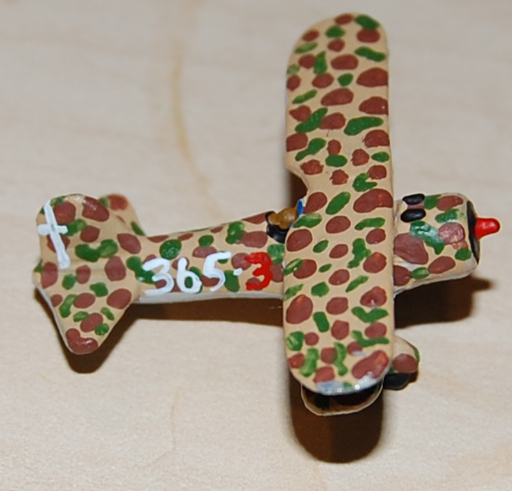

Stage 10 – Apply Decals
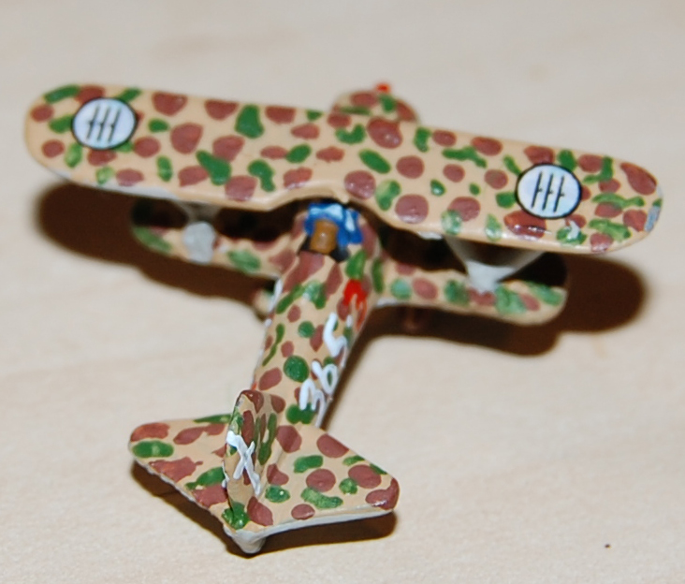

Version 2 scheme

Stage 1 (optional) – Drill base of plane and mount magnet
Stage 2 – Spray whole plane with primer
Stage 3 – Paint upper surfaces Luftwaffe Camo Green
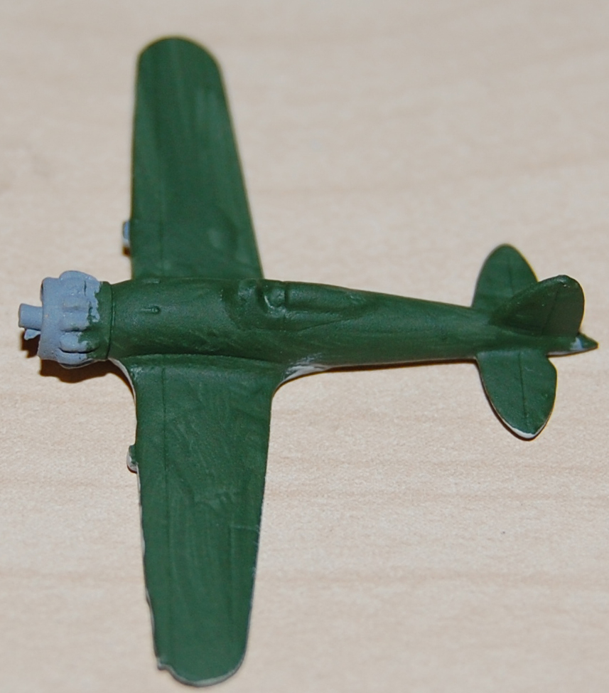
Stage 4 – Paint under surfaces with Deck Tan
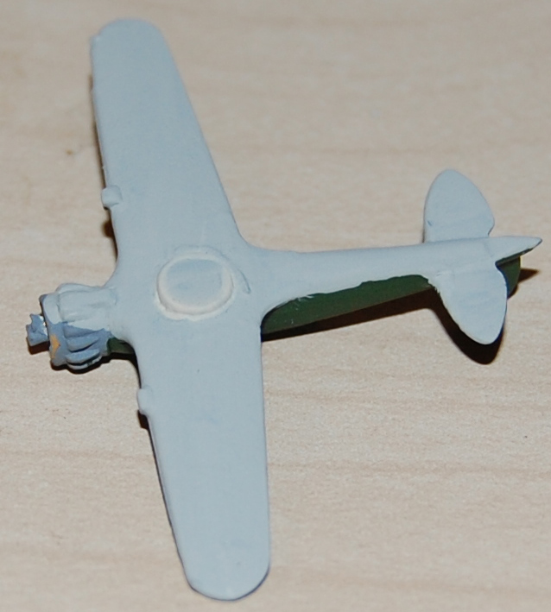

Stage 5 – Paint blotches of Tan Yellow
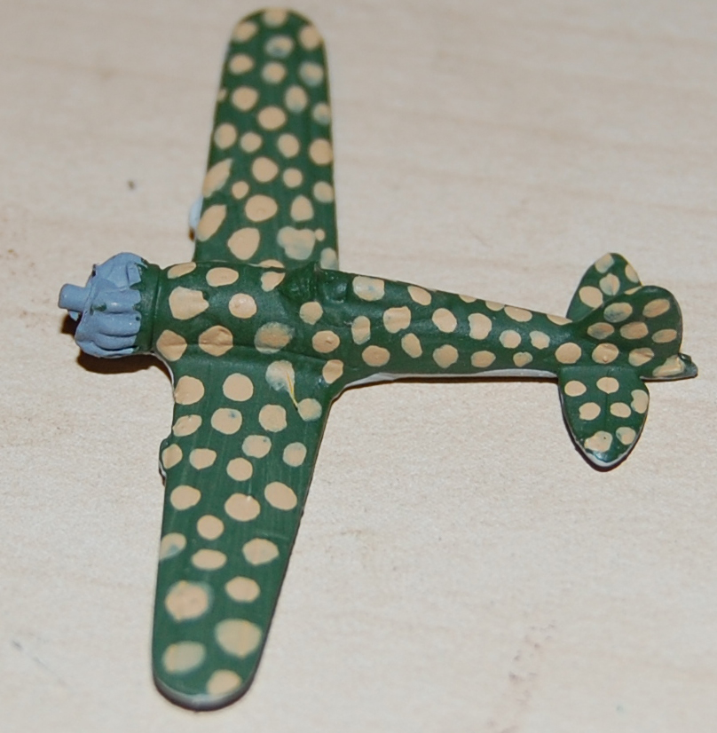

Stage 6 – Paint blotches of Mahogany sand within the Tan Yellow 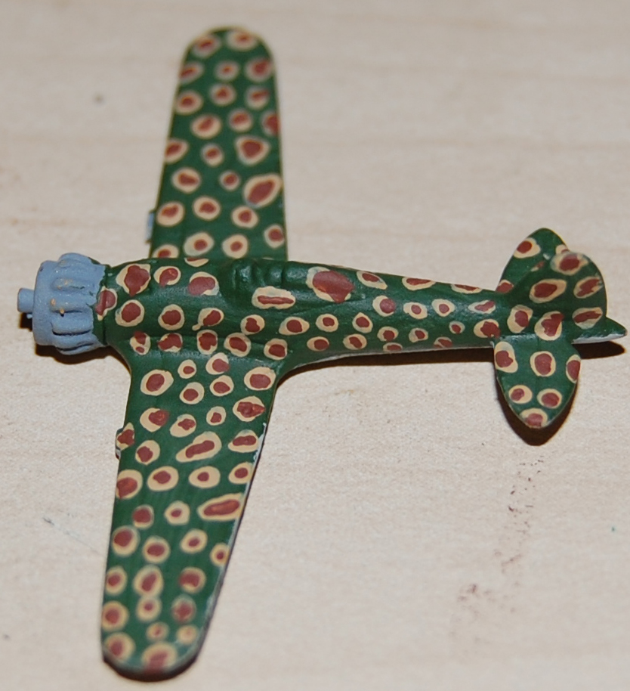

Stage 7 – Paint Engine Yellow
Stage 8 – Paint engines/wheels and open cockpits black, Paint group number on fuselage
Stage 9 – Paint pilot leather brown
Stage 10 –Paint Canopy Prussian Blue
Stage 11 – Drybrush Canopy White/ Paint Fuselage Band / Markings on Tail
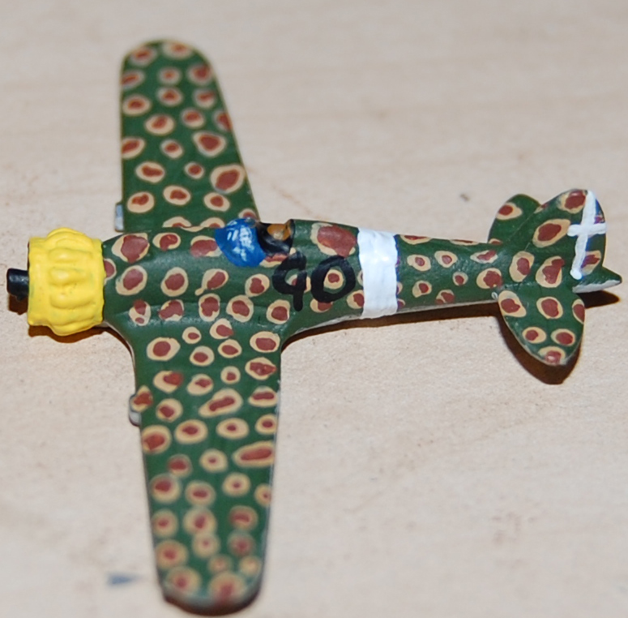

Stage 12 – Paint aircraft number in Red
Stage 13 – Apply decals.

