Equipment needed

Paintbrushes - Size 1,3 and 000
Drill (optional)
Magnets (optional)
Spray can of primer (colour optional – I prefer Grey)
Aircraft model(s)
Vallejo paints – 873 US field Drab
977 Desert Yellow
965 Prussian Blue
961 sky blue
Other colours – Black
White
Red
Decals

Stage 1 (optional) – Drill base of plane and mount magnet
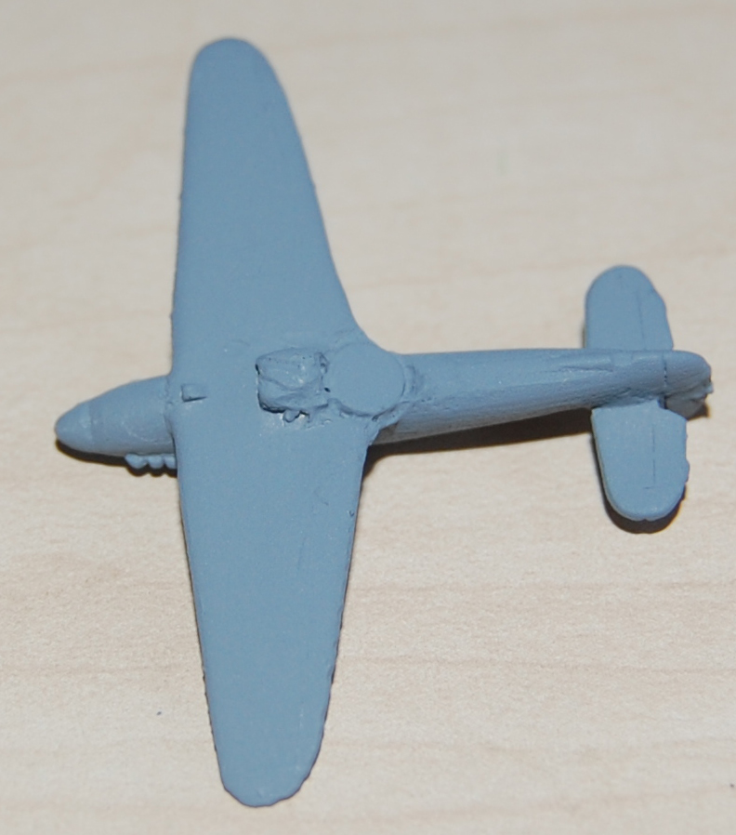

Stage 2 – Spray whole plane with primer (see above picture)
Stage 3 – Paint upper surfaces Desert Yellow
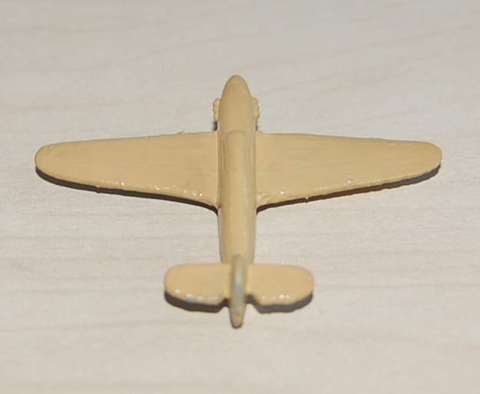

Stage 4 – Paint under surfaces Sky blue
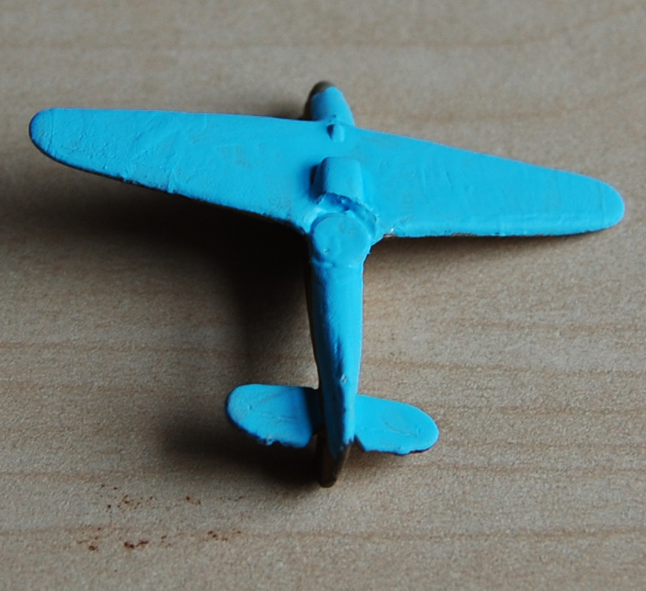

Stage 5 – Paint Camouflage pattern US field Drab
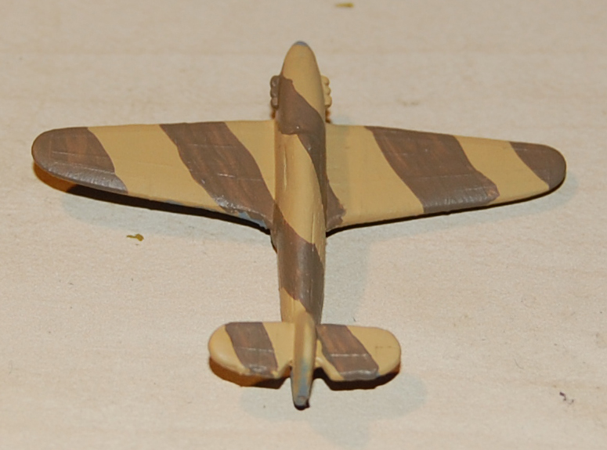
Stage 6 – Paint Canopy Prussian blue and Tail markings
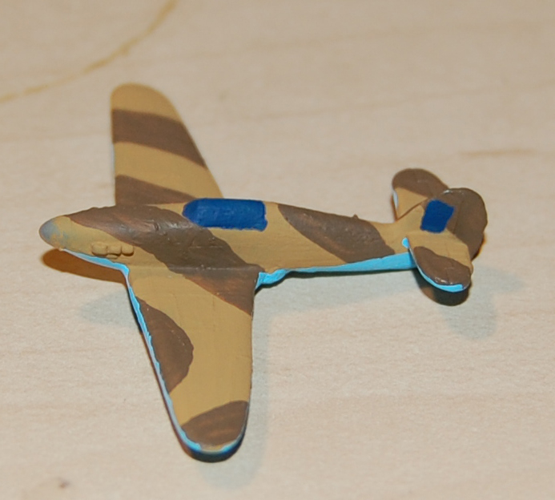

Stage 7 – Drybrush canopy white and tail markings
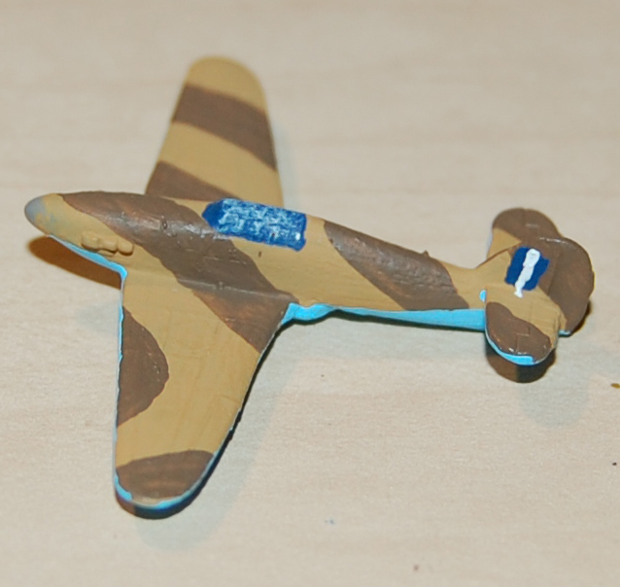

Stage 8 – Paint red tail marking
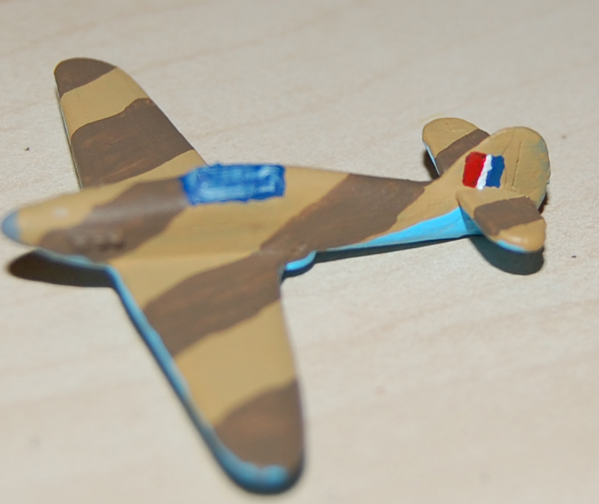

Stage 9 – Repaint canopy lines (note no photo of this stage)

Stage 10 – Paint Spinner and engine exhausts black
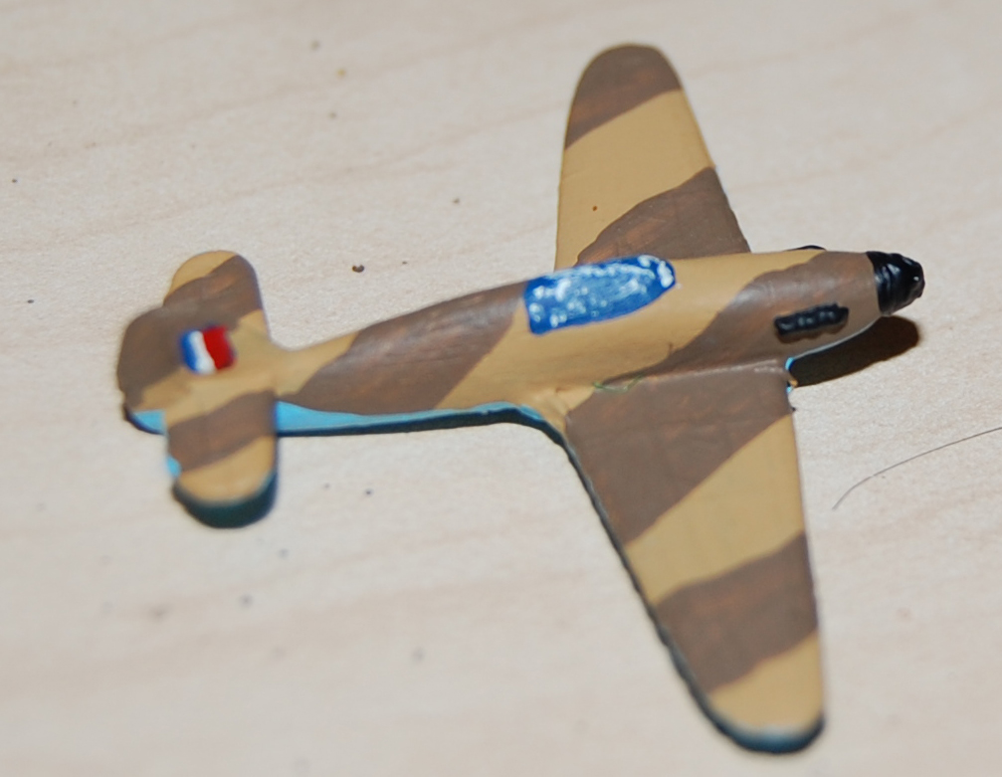
Stage 11 – Apply Decals and paint aircraft code
