Equipment needed

Paintbrushes - Size 1,3 and 000
Drill (optional)
Magnets (optional)
Spray can of primer (colour optional – I prefer Grey)
Aircraft model(s)
Vallejo paints – 823 Luftwaffe camo green
906 pale blue
965 Prussian Blue
Other colours – Black
White
Leather brown
Decals

Stage 1 (optional) – Drill base of plane and mount magnet
Stage 2 – Spray whole plane with primer
Stage 3 – Paint under surfaces pale blue
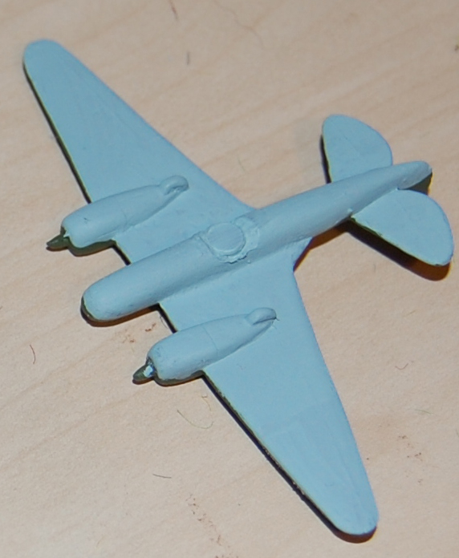

Stage 4 – Paint upper surfaces with Luftwaffe camo green
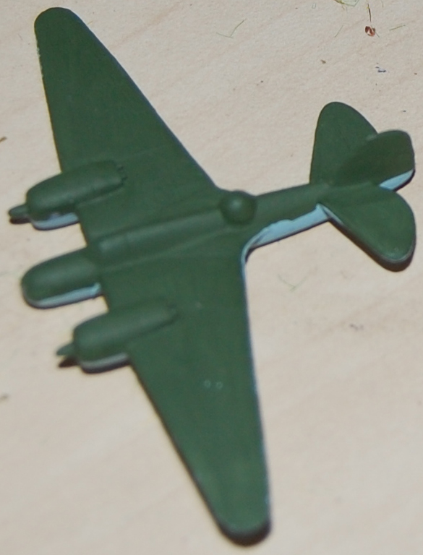

Stage 5 – Paint Canopy Prussian blue
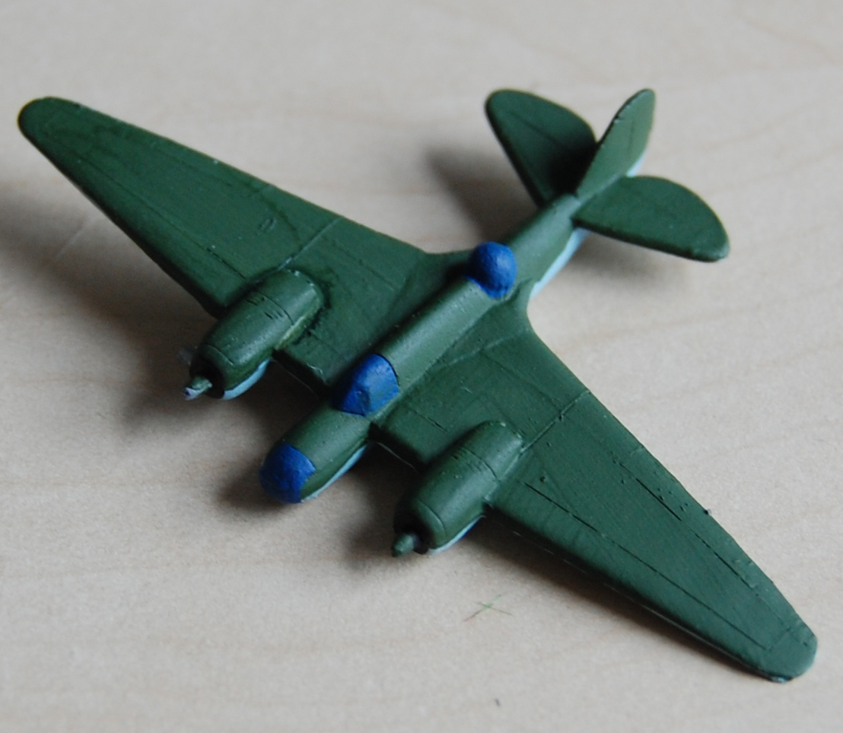

Stage 6 – Dry brush canopy white and add numbers to tail or fuselage
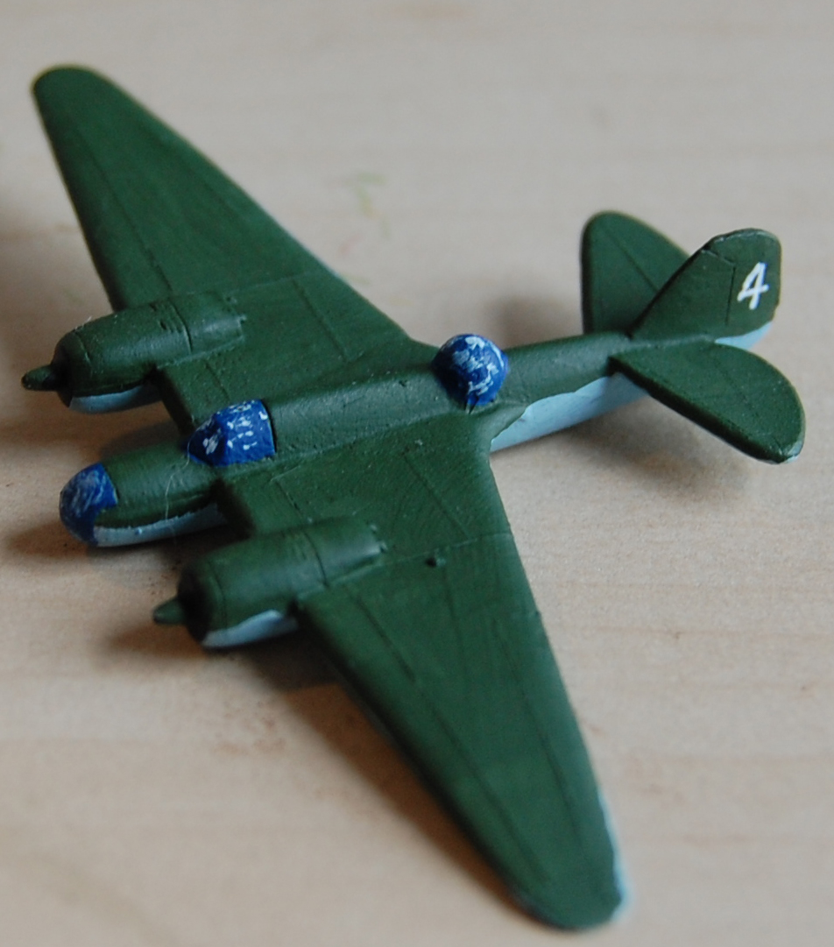

Stage 7 – Paint engines/wheels and open cockpits black
Stage 8 – Paint pilot leather brown

Stage 9 – Apply decals to aircraft
