Equipment needed

Paintbrushes - Size 1,3 and 000
Drill (optional)
Magnets (optional)
Spray can of primer (colour optional – I prefer Grey)
Aircraft model(s)
Vallejo paints – 943 Grey Blue
990 Light Grey
965 Prussian Blue
Other colours – Black
White
Red (optional)
Leather
Decals

Stage 1 (optional) – Drill base of plane and mount magnet
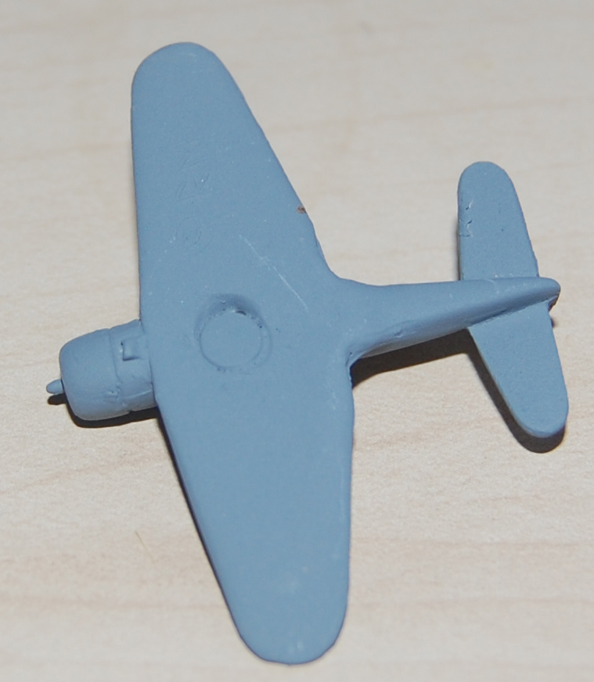

Stage 2 – Spray whole plane with primer
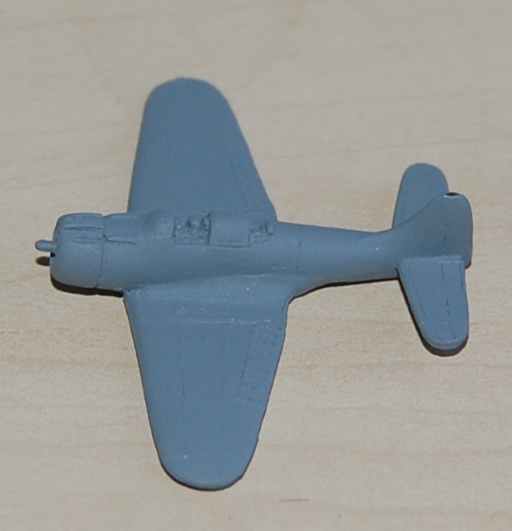
Stage 3 – Paint upper surfaces Blue grey
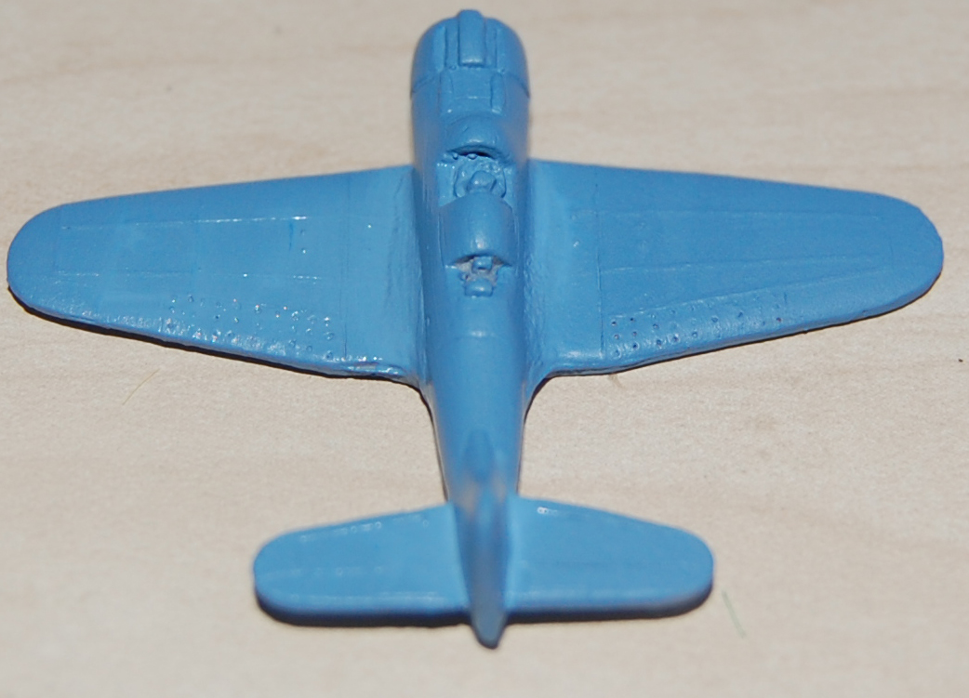

Stage 4 – Paint undersurfaces light grey
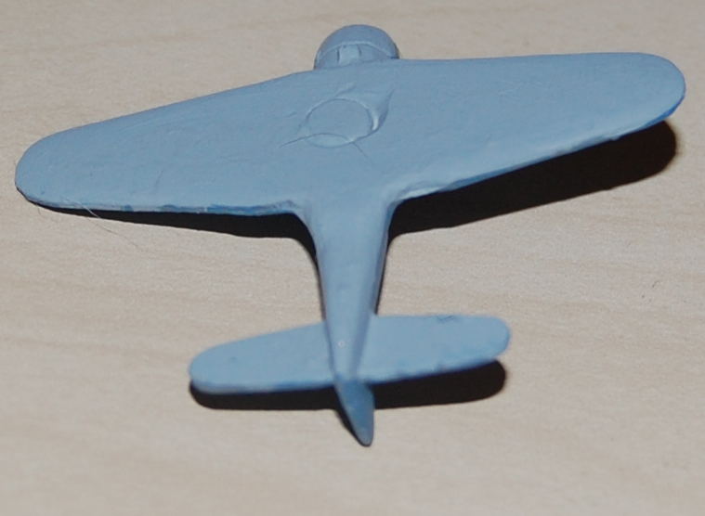

Stage 5 – Paint Canopy Prussian blue
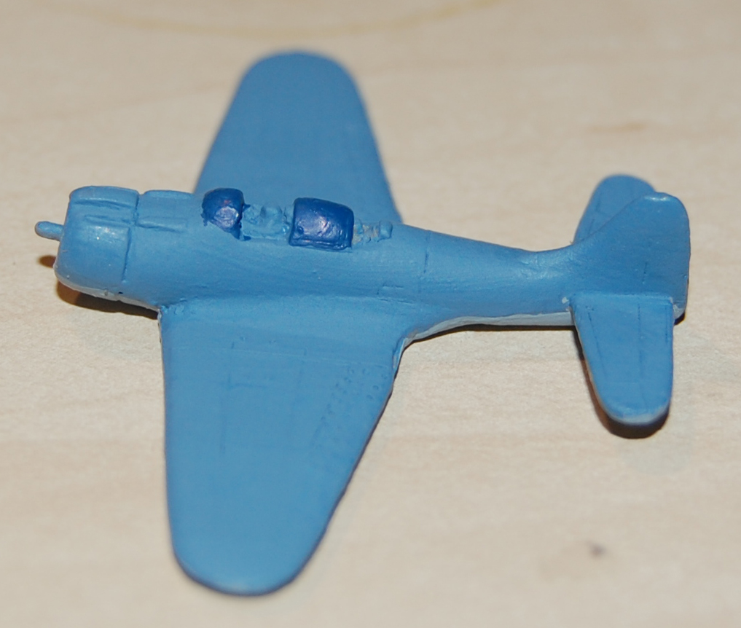
Stage 6 – Paint cockpit Black and crew leather
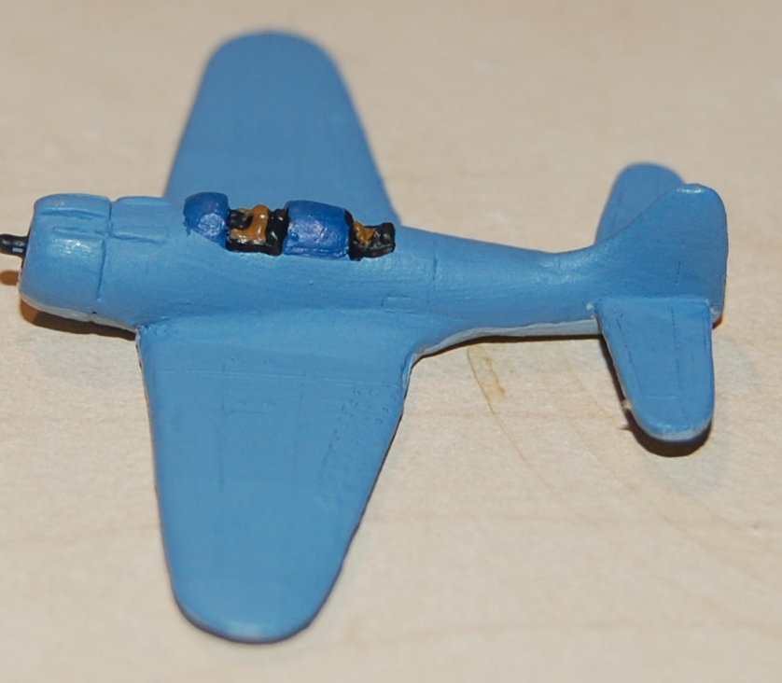

Stage 7 – Drybrush canopy white
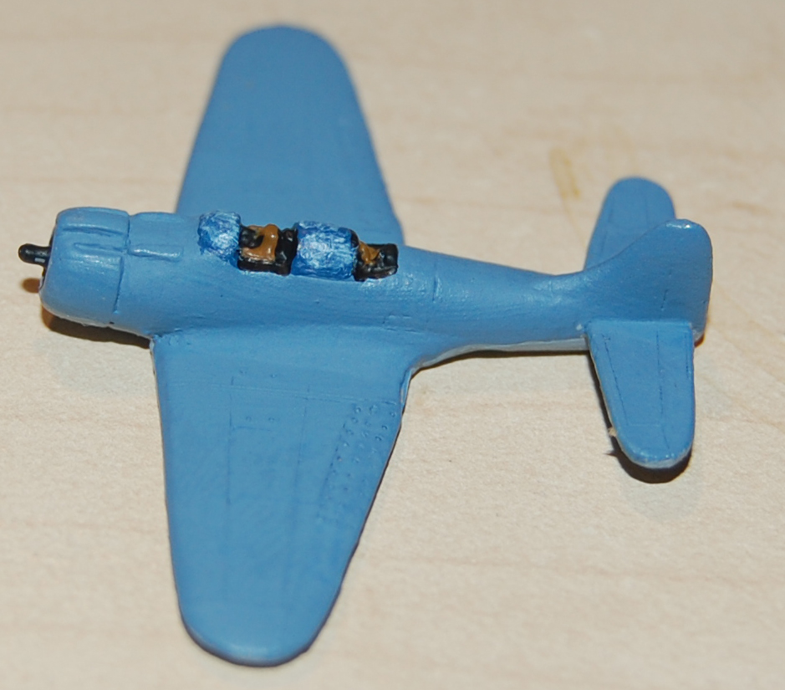

Stage 8 – Repaint canopy lines blue grey (note no photo of this stage)

Stage 9 – Apply Decals and paint numbers (Note – can paint tail white with red stripes if required)
